Sample shipment agreement

NCITU is a BSL-1 (Biosafety Level 1) laboratory with some BSL-2 (Biosafety Level 2) equipment. All samples shipped to or worked on NCITU, SEMC, and NYSBC premises should be classified as BSL-1 or BSL-2 with proper documentation.
If shipping dewars, non-hazardous samples should be packed in a dry shipping dewar. Users should ship dewars via common carrier, such as FedEx. Also, include pre-paid return shipment label. (FedEx is preferred.)
It is the user's responsibility for packages sent to NCITU until an NCITU operational staff member confirms receipt.

NCITU and NYSBC uses a particular numbering system. Please note and order your boxes accordingly.

Bottom
User / Institution
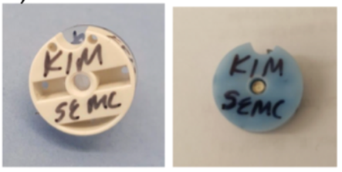
Top
User / Session date
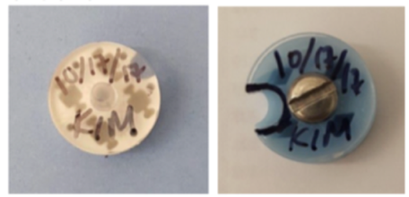
Grid position numbering

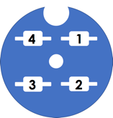

When shipping unclipped grids, please indicate on the shipping manifest whether the sample is facing towards, or away from, the notch.

Acknowledgement

I verify that the samples were packaged by my person and that the samples comply with NCITU biosafety and biohazard policies.

Signature: ____________________________________ Date: ________________
MM/DD/YYYY
Print Name: ____________________________________

